Honda CB400A/CM400A/CM450A/Hondamatic and CM400T Repair Tips
Intro
I’ve gotten quite a bit of emails from customers after replacing their CDIs with other problems they are working on with their Hondamatics. Most things in this guide also apply to the CB400T/CM400T/CM450/CB450SC/etc. I’ve compiled a list of things to do and check to help you get that bike running properly again.
Fuel and Carburetion
General Carb Servicing and Overhaul
If you have leaky carbs, take the float bowls off. You can do this on the bike with a ¼” ratchet and ¼”socket with a #2 bit. Be careful not to round off the screws. Use a drift/punch of the right size and tap lightly to remove the float pins. DO NOT USE A NAIL AND PLIERS! Pliers will put scratches in the pin and cause it to dig into the posts possibly breaking the carb body.
With the float pin out, remove the float and float valve. Take a look at the float valve. If there’s any wear ridges on the Viton tip then it is junk and must be replaced. DO NOT BUY AFTERMARKET FLOAT VALVES! They are inferior quality and usually the wrong lengths which will cause strange running. The part number for the float valves for 78 and 79 years is 16011-382-004. Call up your local Honda dealer and have them order it for you. Alternatively, you can order it from Partzilla. For 80 and later years, the floats are non-adjustable and the part number for those years is 16155-413-751.
For 78 and 79 years you must adjust the float height. Use the proper float height gauge, which can be purchased from Mike Nixon at https://www.motorcycleproject.com. In a pinch, you can measure 15.5mm with a pair of digital calipers and mark it on a piece of cardboard. You should verify float height on 80 and up. Mike Nixon has a video on how to do this at https://www.youtube.com/watch?v=aiexehn33kg.
It's a good idea to remove the carbs and replace the intake manifold o-rings. Part number is 91325-567-005. Inspect the intake manifold rubber for cracks. If they are superficial on the outside, it is probably OK. If suspect, then replace them. There are cheap vendors on eBay with them, but I’ve noticed the tend to start cracking after about 5 years. Plan on replacing them again. Don’t toss your old ones. Keeping the bike stored inside will help them last longer.
If the carb is still leaking after cleaning, new float valves and new o-rings then it’s very likely the float bowl standpipes have a hairline crack or the drain screw. Look carefully along the standpipe and you might see a crack. If you do, then you need to “sweat solder” it. Scuff up the crack and apply a little bit of flux and solder the crack. You can check for leaks in the bowl by filling the bowl with mineral spirits or alcohol. Use a Mityvac set to Pressure and pump about 10-15psi into the bowl from the drain pipe while closing off the top of the standpipe. If any bubbles appear this is a leak you need to fix. Sometimes you may find after you solder the pipe closed that the drain screw is now leaking. Remove the drain screw and clean it up with a wire wheel. Sometimes the seat is a bit corroded or has crud in it. You can use the larger bristles from a welding tip cleaner in there to clean the rest out.
Inspect the airbox rubber boots for tears. Replace them if need be. Part is no longer available, so you will have to search ebay. In a pinch, I’ve heard that rubber cement can work for minor tears but I have not tested this. If you do this, keep on eye on it as it may fail again from fuel vapours.
Replace the air cut off valves and the o-ring in their covers. The aftermarket ones from 4into1 and others are OK. If the old air cut off valve is a bit deformed, but no tears it’s probably OK to reuse. You must replace the o-ring in those covers or it will cause a hard to diagnose lean condition.
For 81 and later: Replace the fuel accelerator pump diaphragm and o-rings. OEM is ideal, but if you must use aftermarket measure carefully. Usually, the length of the rod is incorrect and must be trimmed and filed down. I’ve seen aftermarket ones develop tears after a couple of years, so plan on keeping spares. Again, if the diaphragm on your original is pretty good and seals correctly then you can probably keep it. Just make sure you replace the o-rings.
Fuel crossover and fuel accelerator pump crossover tubes can develop fuel leaks. This makes you think the floats are leaking. To verify, drain the carbs, take it off the bike. Set it on the bench and with a bottle of soapy water spray the crossover tubes where they meet into the carbs. Blow into the fuel line, then look and listen for bubbles in those areas.
O-ring sizes and part numbers from https://www.mcmastercarr.com:
- 1.5mm Wide x 4mm ID x 7mm OD - Accelerator Fuel Bowl - MCM PN: 1295N152
- 2mm Wide x 6mm ID x 10mm OD - Fuel Connecting Tube - MCM PN: 1295N224
- 2mm Wide x 4mm ID x 8mm OD - Accelerator Connecting Tube - MCM PN: 1295N222
- 1mm Wide x 2.5mm ID x 4.5mm OD – Idle Mixture Screw - MCM PN: 1295N113
Don’t use ones from a kit at Harbor Freight/Amazon. Buy proper Viton fuel-rated o-rings from reputable vendors. O-rings in carb kits are questionable. Avoid carb kits at all costs.
The rubber passage plugs are NLA (No Longer Available) from Honda. If yours are rock hard, barely sealing, or floating around in the bowl then replace them. 4into1 sells aftermarket ones that work OK.
If you want to clean the carbs, make sure you remove the air cutoff valves, the fuel accelerator diaphragms (if equipped), passage plugs, floats and float valves. If you don’t do this you WILL destroy the diaphragms. To clean jets and passage ways buy the small sets they sell for cleaning paint guns. Use the smallest size you need to clean these passage ways. In a pinch, a high E guitar string usually works well enough.
When putting it back together it’s ideal to use a JIS screwdrivers. Vessel sells a cheap kit on Amazon that works quite well. You’ll need a #2. #3 will be needed to remove the carb bracket if you need to separate the carbs to replace the crossover tube o-rings. T-Handle JIS screwdrivers are even better. For float bowl screws just get them on reasonably tight. You don’t need to get massive torque on them. They will strip out and cam out easily. The carb bodies are soft metal. So are the brass jets and jet holders. Get everything reasonably snug and then a 1/4” or so turn is usually enough. Be organized, take lots of pictures during disassembly if you must, it’s easy to mix things up.
Sometimes it can be really hard to get the carb back in the boots. Use ‘red rubber grease’ to help ease it in. See my tool recommendations section for a link to this. It’s expensive for a small tub, but lasts a long time. It’s also great for holding o-rings in place (like the intake manifold o-rings!). Make sure the clamps line up with the seats on the boots as you tighten. After you tighten look at the top and bottom and sides, make sure it’s on there evenly. It’s easy to miss the bottom and have an air leak. If the clamps are “maxed out” on tightening and they don’t feel very tight on the boots then the clamps are probably stretched or worn. Part number for the intake clamps: 16219-ME9-000. Part number for the airbox clamps: 95018-60250.
If you break or strip something out on the carb, or even after all this effort you still cannot fix the leaks or poor running (even after you’ve verified other conditions in this guide) I highly recommend you have Mike Nixon re-do your carbs. It’s expensive, but well worth it. Factory trained, career mechanic. He only uses OEM parts. It will be done right. Send him a line at https://www.motorcycleproject.com.
Synchronization and Pilot Mixture Adjustment
To do the carb synchronization start the bike and get it to operating temperature either by allowing the bike to idle for about 10-20 minutes with a shop fan pointed at it or drive it for about 10 miles. Shut the bike off and remove the gas tank. Hook a carb sync gauge and portable tach, the vacuum ports are located near the carb insulators on the cylinder.
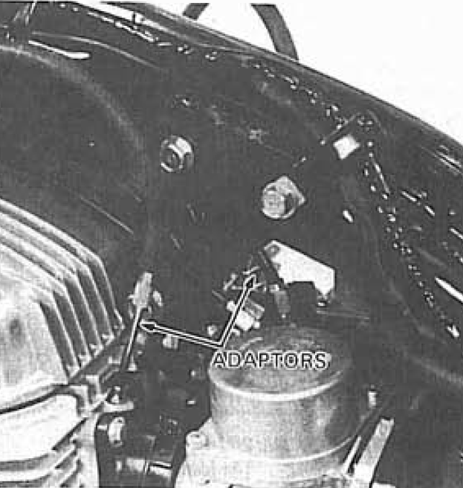
When attaching the gauges to the vacuum ports it’s best to put a little bit of grease on the threads and vacuum line as to not introduce a vacuum leak that will affect the gauges and possible stall the engine.
Start the bike and adjust the idle to 1250RPM (1200 for 400Ts). Note the gauges. The vacuum readings should be equal to each other and target is 20-24cmHg. If they are not, loosen the 10mm nut while simultaneously keeping the flathead adjuster in place. Now turn the flathead adjuster in or out to get the same reading on both gauges. Watch the gauges as it will take a few seconds for the readings to stabilize. Blip the throttle. If the idle goes above 1300 RPM then reset the idle and check again. Make sure you are blipping the throttle after adjustment. When you are satisfied with the adjustment tighten up the lock nut and blip the throttle again. You may find the reading has changed. You may have to back off the adjuster and tighten again to get it where it needs to be. Just like doing valve adjustments.
When you have the carb sync completed now you can do the pilot mixture adjustment. With carb sync gauges and portable tach still attached make sure the target idle is correct. Turn mixture screw in slowly, until engine starts to stumble/die out. Back off on the screw about 1/8-1/4” so it no longer stumbles. If you find that turn the screws the whole way in does nothing then you have a blockage in the idle circuit, o-ring, washer or spring is missing under the mixture screw, or the tip is broken/deformed on the mixture screw. Fix the problem and do the procedure over.
Note reading on gauges (for example 20cmHg), blip the throttle. If the vacuum drops to say 14cmHg and then “recovers” back to 20cmHg the mixture is too rich. Turn the mixture screw IN to lean it out. Not too much, about 1/8-1/16 turn at a time. Again, if idle goes past 1300RPM then adjust again to target. Blip the throttle and note the reading. If the vacuum goes above your target and then settles back the mixture is too lean. Turn the mixture screw OUT to richen it. The idea here is to get it so when you blip the throttles the vacuum always returns to the same spot every time with no dips or rises.
Checking Petcock Fuel Flow in All Positions
Top off the tank, remove the fuel line, attach a longer fuel line hose and run this hose into a mason jar as to minimize mess. Turn the petcock to the ON position. Note if fuel is flowing and make sure it’s not rusty/brown looking. If it is, inspect the tank and clean it with a de-ruster such as evaporust. DO NOT LINE THE TANK. THE LINER WILL LIKELY FAIL, CAUSE FUEL CONTAMINATION, FLOAT VALVES STICKING OPEN AND BLOCKING PASSAGES IN YOUR CARB! Now move the position to OFF. Wait a moment and make sure there is no fuel dripping out. Any fuel dripping it out, even a tiny amount, means the gasket in the petcock is deformed. This is bad and could cause fuel to leak out the drain pipe, into the airbox or even into the engine causing hydro lock and fuel-contaminated oil. Once you’re positive the OFF position is good now move to the RES position. Again, make sure it is flowly freely and cleanly. If not, the gasket is deformed. If your petcock is faulty find a new OEM one or use a rebuild kit. DO NOT USE AFTERMARKET PETCOCKS. THEY’RE USUALLY MADE OF INFERIOR MATERIALS FOR THE PETCOCK GASKET AND TEND TO BE CLONES INTENDED FOR SCOOTERS. IF THEY WORK NOW, THEY WON’T FOR LONG AND WILL CAUSE LEAKS IN THE OFF POSITION OR STAY STUCK IN ONE POSITION. THE “ACTION” ON THE LEVER TENDS TO GET FUNNY AFTER A WHILE.

Dropping the float bowls while on the bike
You can remove the float bowls while on the bike. This allows you to clean the seat if sediment keeps the float valve stuck open, replace the float valve, repair the standpipes, clean the float bowls, set float height, and replace the idle passage plugs. To do this, simply take a ¼” ratchet with a ¼” socket and a PH2 or JIS2 (preferred) bit. Get it parallel to the surface when removing and it will come off. It’s a bit tight, especially around the neutral/change switch but doable. Alternatively you can use a low-profile ratcheting screwdriver. See the end of this document for tool recommendations.
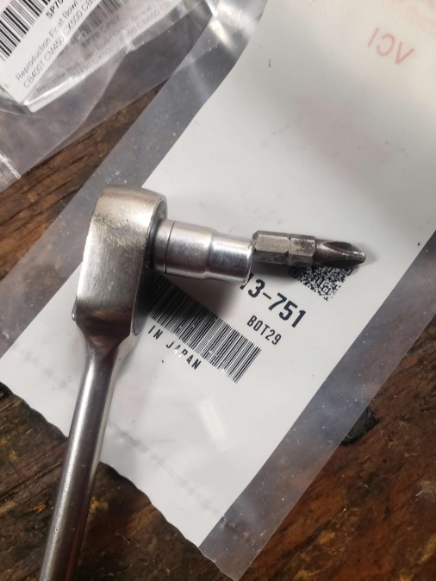
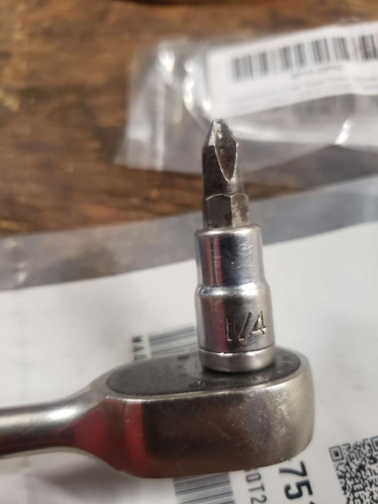
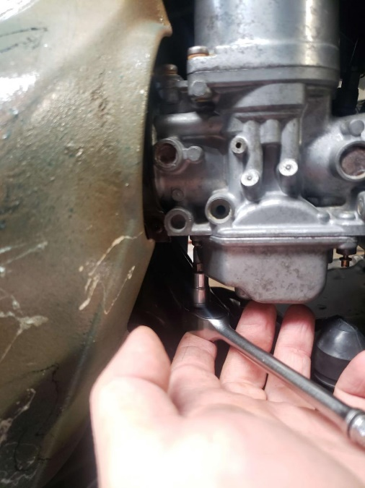

Repairing the Petcock with Aftermarket Kit and Tap
TODO

TODO: check airbox for blowby crud, draining the blowby with the two plugs at the bottom of the bike.

Electrical
Cleaning, Inspection, and Servicing of Terminals
Most electrical problems on this bike (and other vintage bikes) are from faulty connectors. Where the 6-pin connector comes out of the stator, disconnect it from the CDI. Look at the connectors. If they have any corrosion on them then use a small pick tool or very small flathead screw driver to remove the pins and clean the corrosion off. If it’s really bad and you see green corrosion at the crimps the wire is garbage and you must trim it back until you get good wire. If you run out of slack for this, then Matt at Vintage Connections, https://www.vintageconnections.com, sells the right wire colours and the special fibreglass insulation for the stator wires. He also sells the proper crimp tool, OEM connectors and other things you need to fix wiring. The tool is pricy, but if you use it once you’ll agree it was money well spent.
Take a look at the 2-pin green/yellow connector that goes from the CDI to the coil. Again, if there’s any corrosion then fix it. Do the same for the 2-pin white/blue connector from CDI to stator, and the bullet connectors that go to the change relay.
If you have intermittent issues where the main fuse likes to pop take a look at the ground wires. There’s the ground that runs from stator to 6-pin connector and from there to CDI. There’s also a ground eyelet that runs from the headlight harness to where the CDI mounts on the right-side bolt. Clean up any corrosion there. If you had the frame repainted it’s easy to forget to mask this off. Clean it up, then use some anti-seize compound where the CDI meets the frame and eyelet. This will help with corrosion, but it is also conductive.
If the main fuse is finnicky and the bike just shuts off and you have to wiggle around the main fuse to get it to come back then the best thing to do is replace the fusebox. Vintage Connections has an aftermarket one if you want to stay mostly original. Otherwise, you can get waterproof inline fuse connectors from the auto parts store and change them over to regular blade fuses. If you do this, make sure you solder, NOT AUTOMOTIVE CRIMPS, and heat shrink these connections.

Spark Plug, Caps, and Ignition Coil Servicing
Replace spark plugs and caps. Use genuine NGK parts. You can get these from your Honda dealer, and they likely have them in stock already. David Silver Spares (https://www.davidsilverspares.com) also sells them and so does Partzilla. Don’t order them from Amazon or eBay unless it’s a reputable vendor. Unfortunately, there are counterfeit NGK products out there. You will need NGK D8EA spark plugs and NGK XD05F caps. Trim back about 1/2" or so of wire after you take the old caps off. Install the new ones. For new spark plugs, get them finger tight then go about a 1/4" to 1/2" turn. If threads are a bit rough then you may have to go a little more, but use common sense. You don’t need to he-man them on; the cylinder is aluminum. UPDATE: AS OF JUNE 2023 NGK IS NO LONGER MANUFACTURING SPARK PLUG CAPS. YOU WILL NEED TO GET AFTERMARKET OR CRIMP YOUR OWN. IF YOU GET AFTERMARKET CHECK THE CAP RESISTANCE. IT SHOULD BE 5K. IF IT’S OVER IT IS NO GOOD. CHECK FOR FITMENT AS WELL!
TODO: Dynatek DC11-2 coil, verify timing, voltage drop tests, ammeters, peak voltage adapter tests on stator and coil, corrosion on turn signal mounts under lenses, corrosion and cleaning of bulb sockets, hydrometer test, importance of overflow tube on lead acid batteries, cleaning the 2-pin red and red/white from reg/rec to battery.

Brakes
TODO: Flushing out DOT3, new seal, cleaning where seal seats with Dremel wire wheel, sil-glyde on seal and piston, replacing master cylinder reservoir o-ring, replacing master cylinder plunger, cleaning cam on rear brake and adjustment, DOT5 conversion.
Engine
Compression Check
Before you begin work on the bike or start riding it do a compression check. Get a real gauge, not a $20 one from amazon as they are inaccurate. OTC sells a kit for about $100 that is comparable to a Snap-On tester. With the throttles wide open and choke OFF/down crank the bike until the gauge is no longer going higher on the reading. If you have a kickstart only model you may have to kick it over about 10-20 times. Note the reading for each cylinder. If it is under 150psi you are getting into rebuild territory. Stock compression for these bikes is 184psi, but it’s common to see 160-170psi on a well-maintained bike. Before you freak out and think it needs the rebuild do the valve adjustment.
Valve Adjustment
To do a valve adjustment the engine must be COLD. Remove the gas tank and remove the two 10mm bolts on the valve cover. You will need to replace the rubber grommets on these bolts as they harden with age and will cause an oil leak. Part Number is 90441-413-830. Now you can remove the cover. It’s a bit tricky. Slide it forward at 45-degree angle and then it should slight out the left (by the CDI). If you find this too difficult you can remove the Ignition Coil and the CDI. Remove and replace the valve cover gasket. Part Number is 12328-413-830. If you don’t do this you will get a slow oil leak. Remove the spark plugs, be careful not to drop dirt in the cylinder. You can remove them with a 19mm socket. Remove the gear shift lever. It will be held in with a 10mm nut. It may be difficult to slide it off the spline. You can, very carefully, get a flathead screwdriver wrapped with a shop towel and lever it off. Make sure not to mar the stator cover or damage the splines. Remove the stator cover, it’s held in with 8mm bolts. Be mindful as you remove them as the bolts are different lengths. The gasket is no longer available, there are aftermarket ones available and it can be found NOS. If the gasket is in one piece you can reuse it. Part number for this gasket is 11492-413-306. Now, spin the stator counter clockwise and line up the ‘T’ mark to the triangle pointing down on the crankcase. It’s located above the stator.
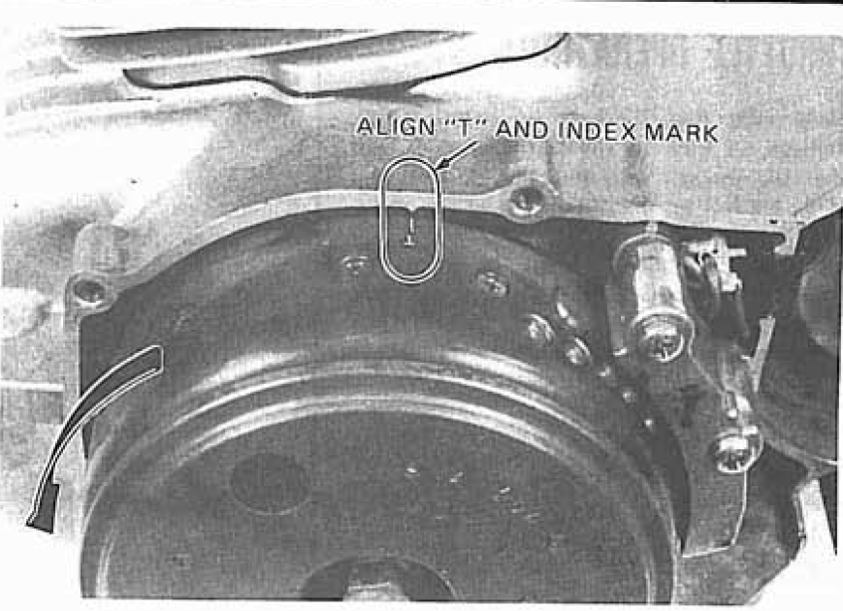
Check the rockers on each side. One of the cylinders should have all rockers loose. This is the side you check the clearances. With a set of feeler gauges check the gap. Intake is the side pointing towards the carburetors. There are two valves on this side. The exhaust valve is well… pointing towards the exhaust! Clearance spec for Intake is 0.10mm +/- 0.02mm and Exhaust is 0.14mm +/- 0.02mm. It is better to set them on the looser side of the scale. I.e., for Intake set it around 0.12-0.14mm and for Exhaust set it to 0.16-0.18mm. This well help with receded valves and will not harm anything. To set the valves, use a stubby flathead screwdriver and loosen the 10mm nut with a wrench. They may be hard to loosen if it hasn’t been done in a long time. To check, insert a feeler gauge. The easiest way is the “go-no-go” method. I.e., if a 0.16mm gauge fits but a 0.18mm does not then the clearance is 0.16mm. You can use a 10mm socket to get it loose. Put your feeler gauge in, set to the proper clearance and tighten the 10mm nut while keeping the adjuster in the same position. Check it again. You may find that it has tightened up. If yes, a trick is to set it one or two ranges higher. I.e., your target is 0.16mm, you tighten it drops to 0.14mm. Put a 0.18mm feeler gauge and tighten it down.
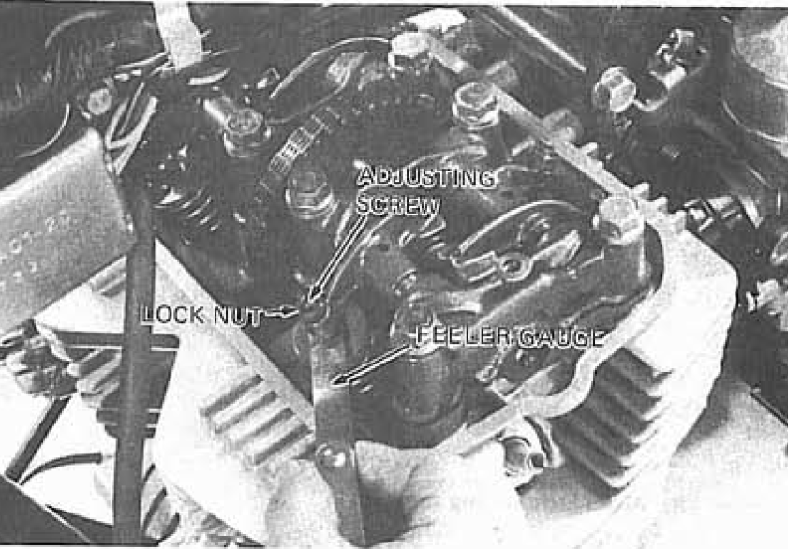
Now rotate the flywheel again until it reaches the ‘T’ mark again. Check the opposing cylinder, those rockers should now be loose and you can adjust. Once you are satisfied with the adjustments, put everything back together. Again, use a new valve cover gasket and new rubber grommets for the valve cover bolts or you will have a slow oil leak from the valve cover. When installing the new gaskets put a skim coat of grease on them to help them stay on during assembly.
Check your compression again, you may find that it has gone up! If it’s still under 150psi you really need to start thinking about getting new valves, valve seats cut for the new valves, etc. and the cylinder rebored. You can use a leak down tester to verify which parts need replaced and machined… but it’s best to do the whole top end if you are at this point. If you decide to go that route only use OEM gaskets, o-rings and seals. Gasket kits cause leaks. When tightening the cylinder head bolts use an inch pounds torque wrench, NOT a foot pounds torque wrench!

Cam Chain Adjustment
Once you get the bike running, adjust the cam chain. It’s very easy to do. With the bike running loosen the 10mm nut on the cylinder, closest to the crank case. Don’t remove it, just loosen it. You will hear a bunch of cam chain noise in the head. Now tighten it back up. This loosens the automatic adjuster to the correct slack.
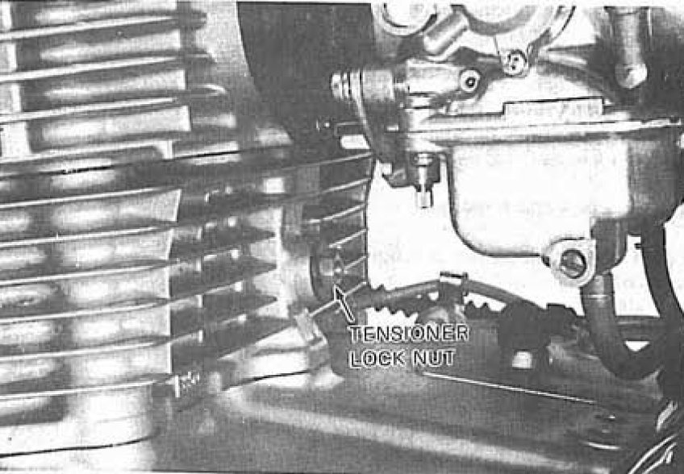

Balancer Chain Adjustment (400A/450A/Hondamatic)
If the bike is at least 10,000 miles you must do the balancer chain. This is a bit more involved, and should be done every 10,000 miles. Before you begin, there are critical parts required.
Parts Needed
- Torque Cover Outer Gasket - 11394-417-000 -- NLA, source via DSS, eBay, CMS, etc. 4-into-1 has a gasket kit. Unknown if fitment is correct.
- Torque Cover Inner Gasket - 11393-417-000 -- NLA, source via DSS, eBay, CMS, etc. 4-into-1 has a gasket kit. Unknown if fitment is correct.
- Torque Cover Inner O-Ring - 91301-706-000 -- McMaster-Carr Replacement: 1185N96

Start by draining the oil. After it's drained, I put the bike on the side stand to minimize mess when the torque converter cover comes off. Lay some towels down as there will be some oil.
Remove the foot peg, two bolts.
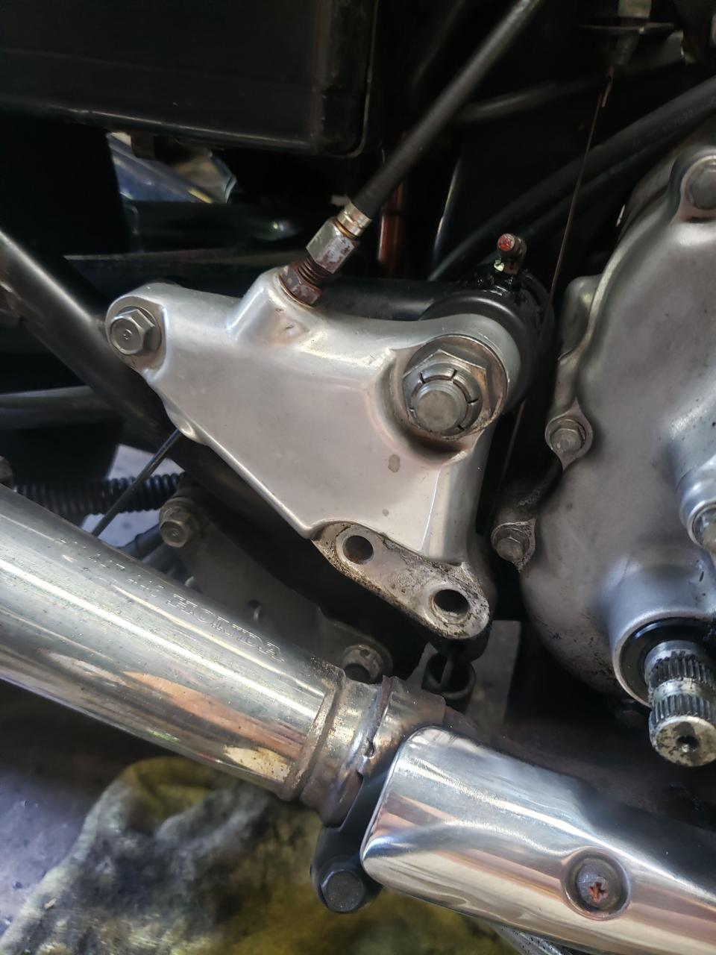

Remove the outer cover, all 8mm. In my case they were on kind of tight as it's never been removed before. When using a 3/8" socket I didn't have confidence in it so I used a breaker bar to help get the bolts started. Made quick work of it.
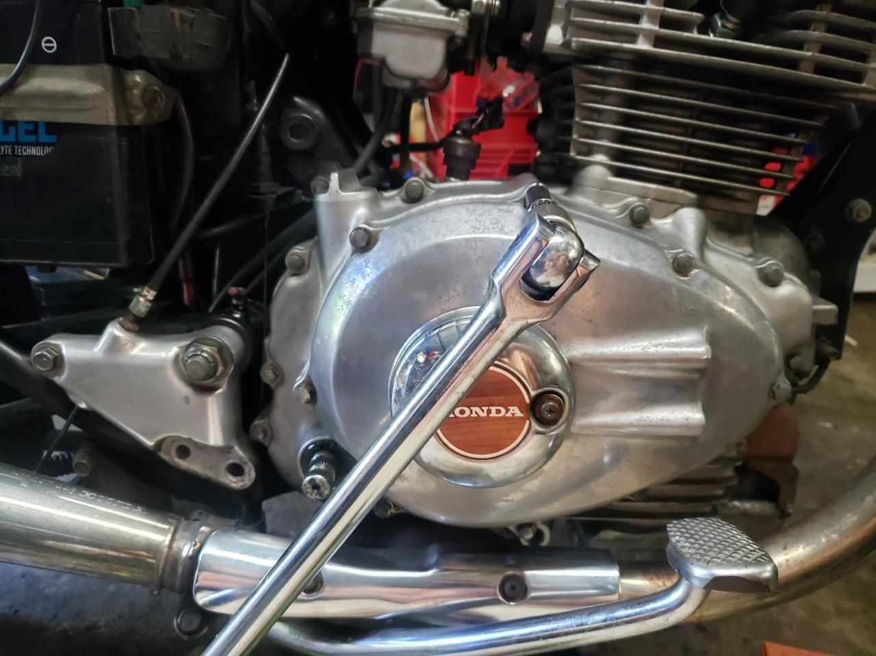
Lay the bolts out and keep them organized, they are different lengths.
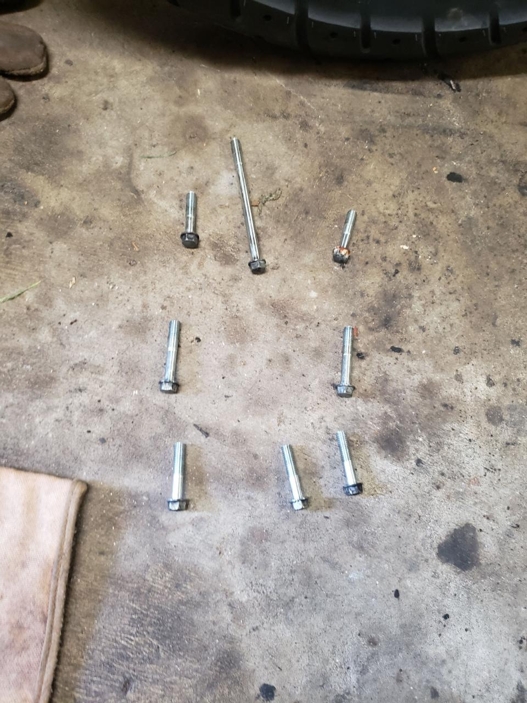

The cover may be difficult to get the removal procedure started as it's likely never been serviced before. I used a rubber mallet to start it, and from here used a plastic wedge carefully to continuing getting it off.
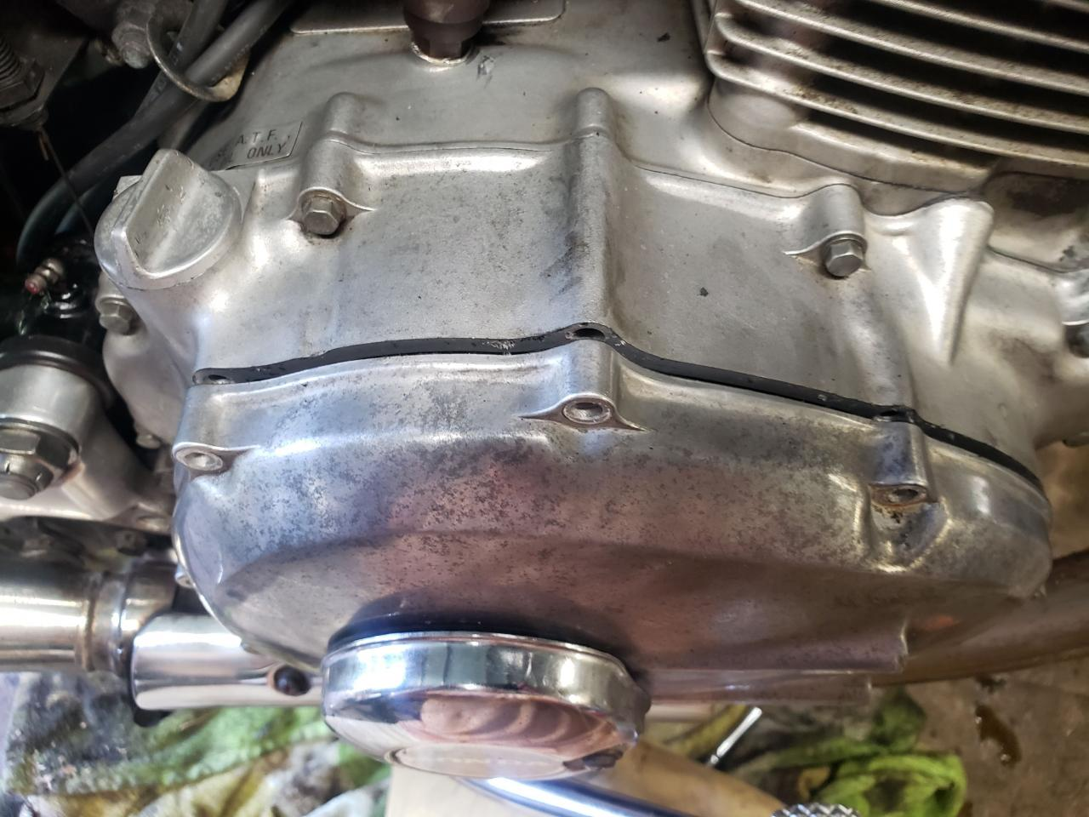
Torque converter now exposed. Note the roller bearing is on the torque converter. This should not be normal, but in my case it was because the engine was still warm. It should be on the inside cover. If it's not then heat the case and cool the bearing. It's an interference fit and the NTN logo/writing goes on the side of the torque converter.
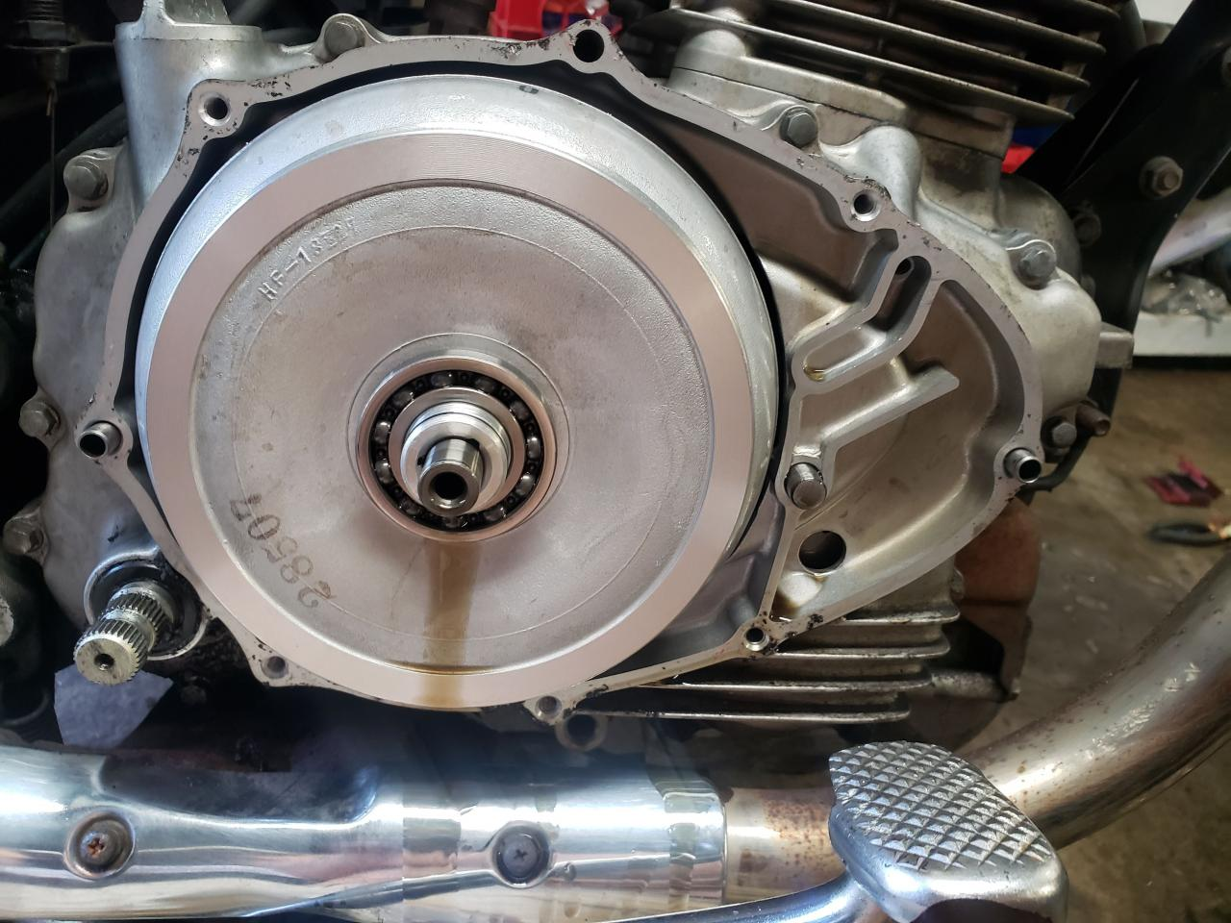

There is a dowel pin and an oil check valve on the right side. Be incredibly careful with the check valve. It's simply a spring and the housing. Remove it and set it aside to keep it safe.
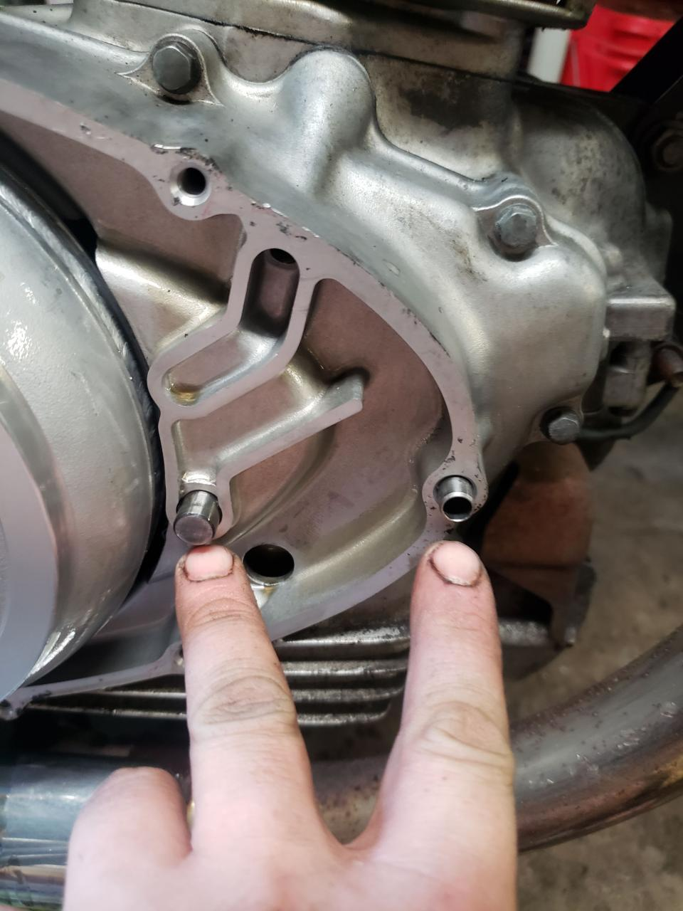
There is also a dowel pin on the left side. It is the same size as the one on the right. Remove it with the others and keep it safe.
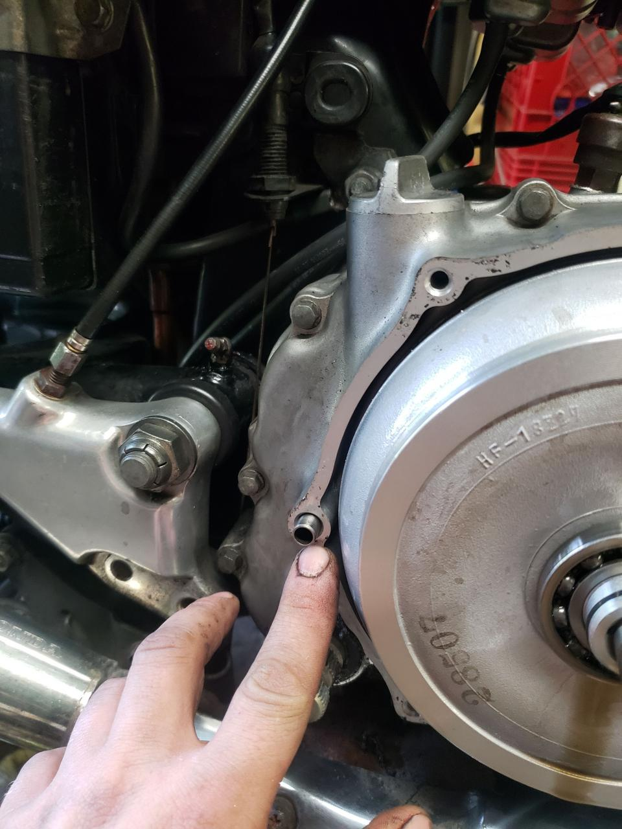

Take a shop towel and a flat head screw driver and very carefully pry from the top right to remove the torque converter. Have towels as oil will spill out.
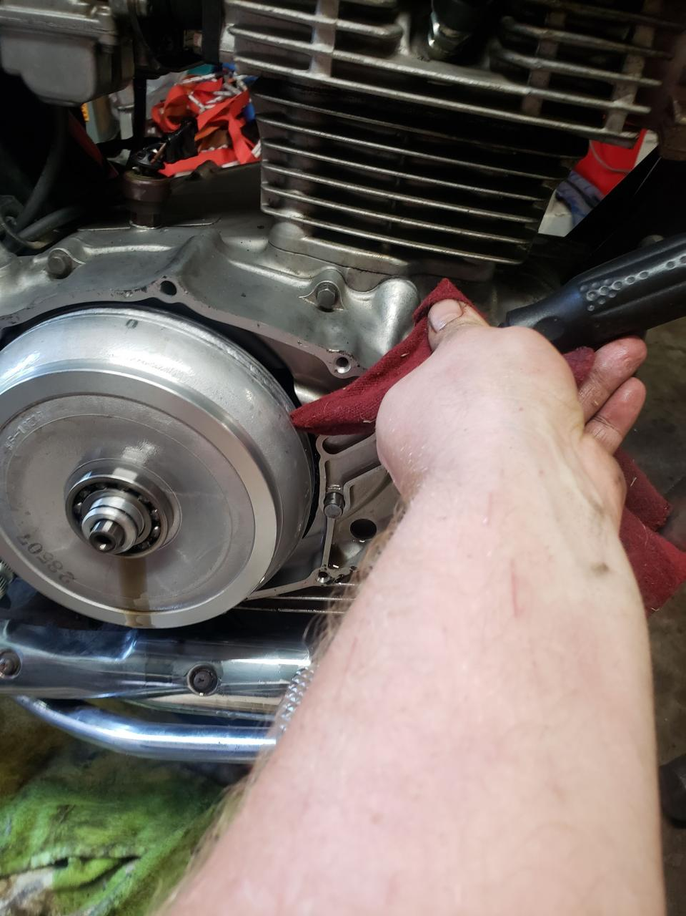
There are two needle bearings. They are the same size. One (or both) may be attached to the inside of the torque converter. In my case they were on the shaft. Set these aside or simply leave them on the shaft.
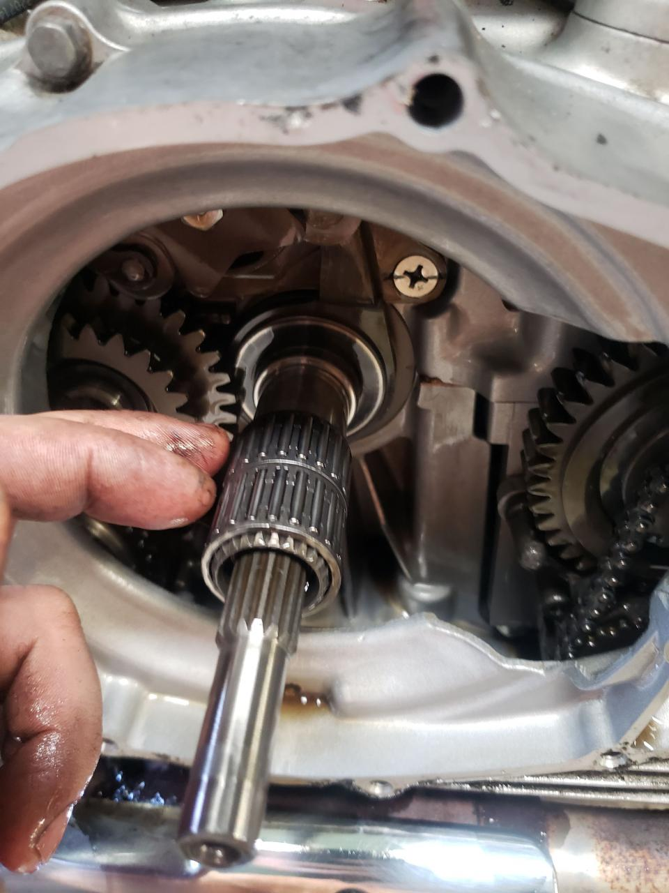

Remove the 8mm bolts for the inner cover. The book wants you to remove the muffler to do this. But, if you're careful you can remove it without having to do this. Remove the accessible bolts, then with a tiny 8mm wrench remove the lower two on the right that are blocked by the muffler. Mine were a bit tight so I used a rubber mallet on the wrench to get it started. Be careful doing this. If you have some long wrenches for small metric sizes it would be easier, but I don't. Again, bolts are different lengths so keep them organized.
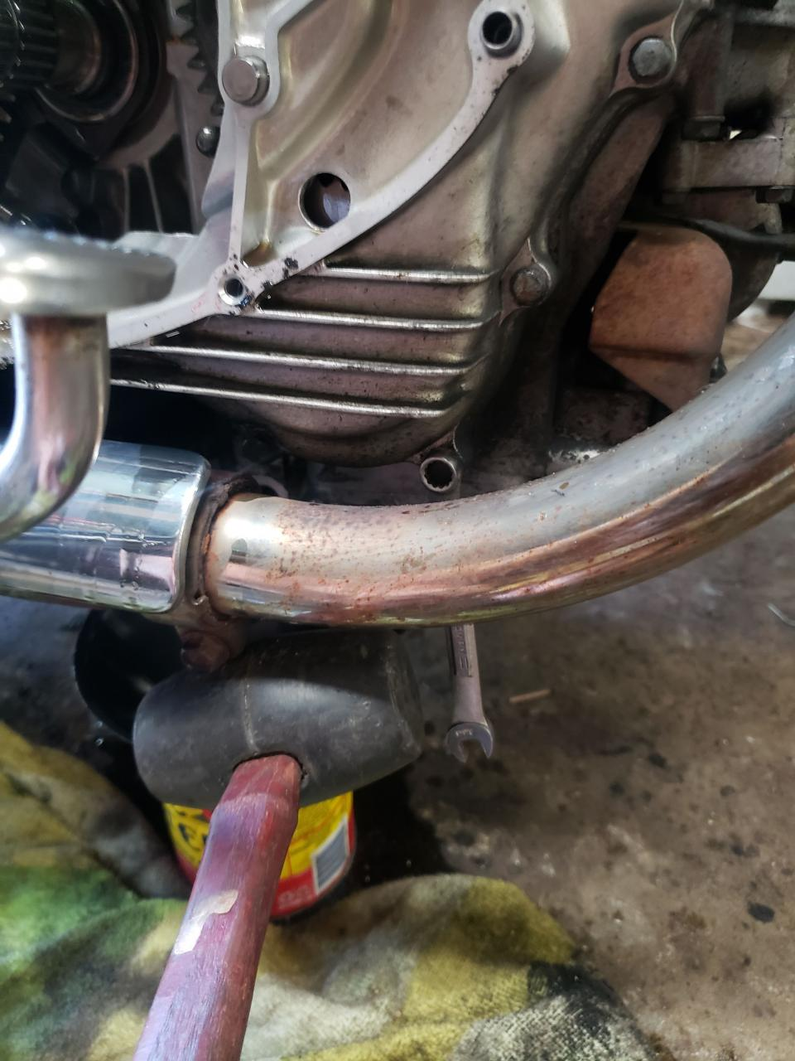
There is also a bolt hiding dead center at the bottom of the cover by the muffler heat shield. Don't forget this one.
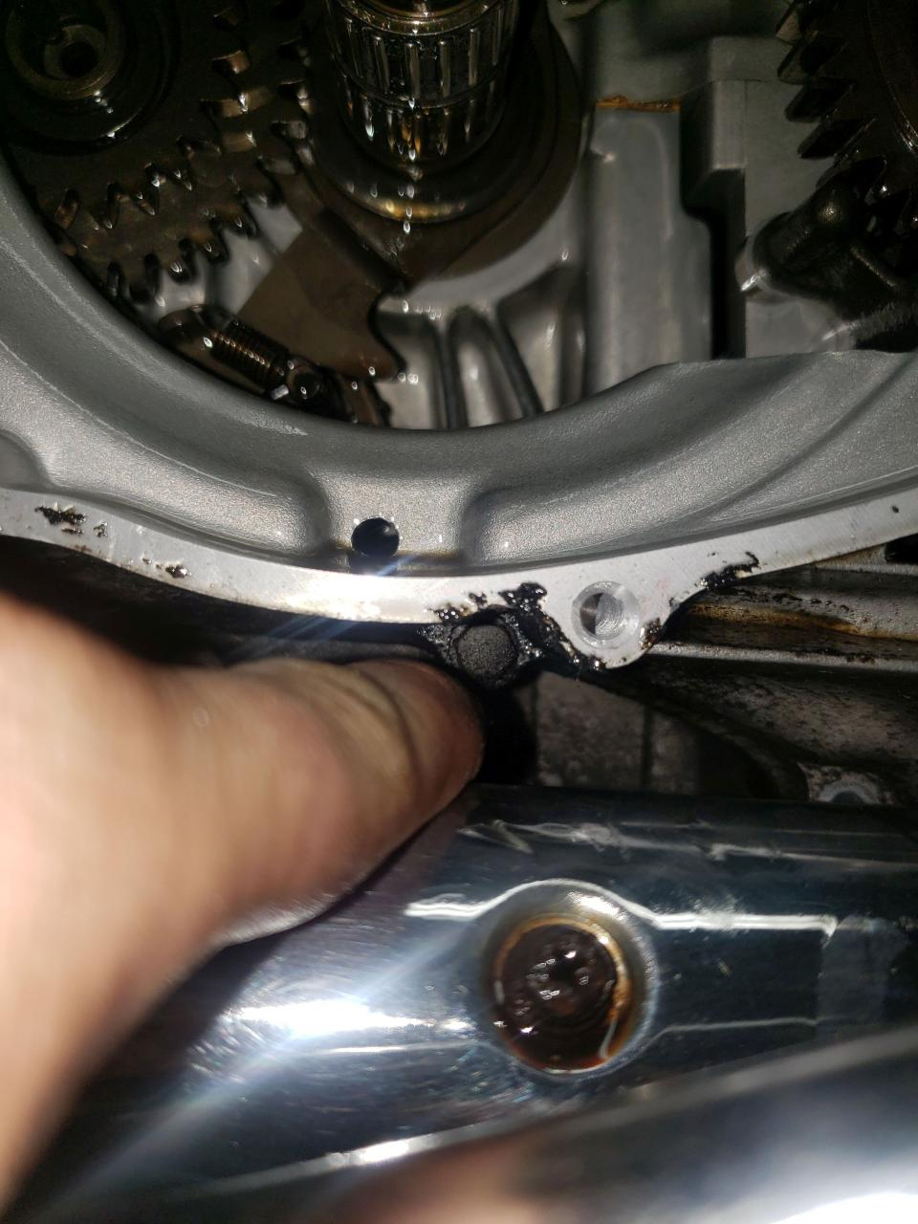

To remove the cover with the muffler attached you will have to pull out about as far is it goes then turn the cover counter clockwise to clear it. It will make it.
Inner Cover removed:
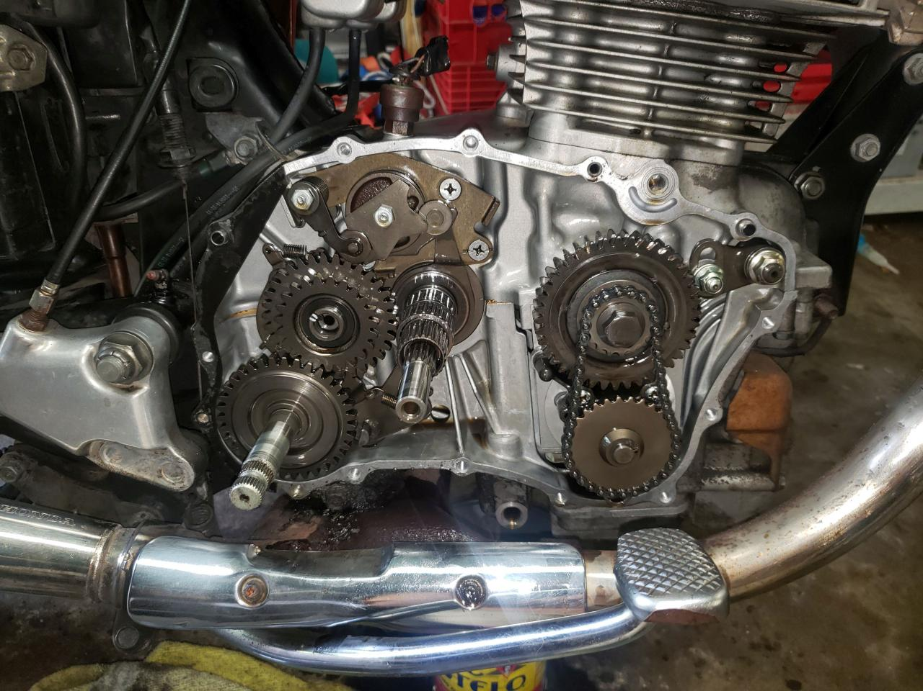
There is a dowel pin on the left, watch out.
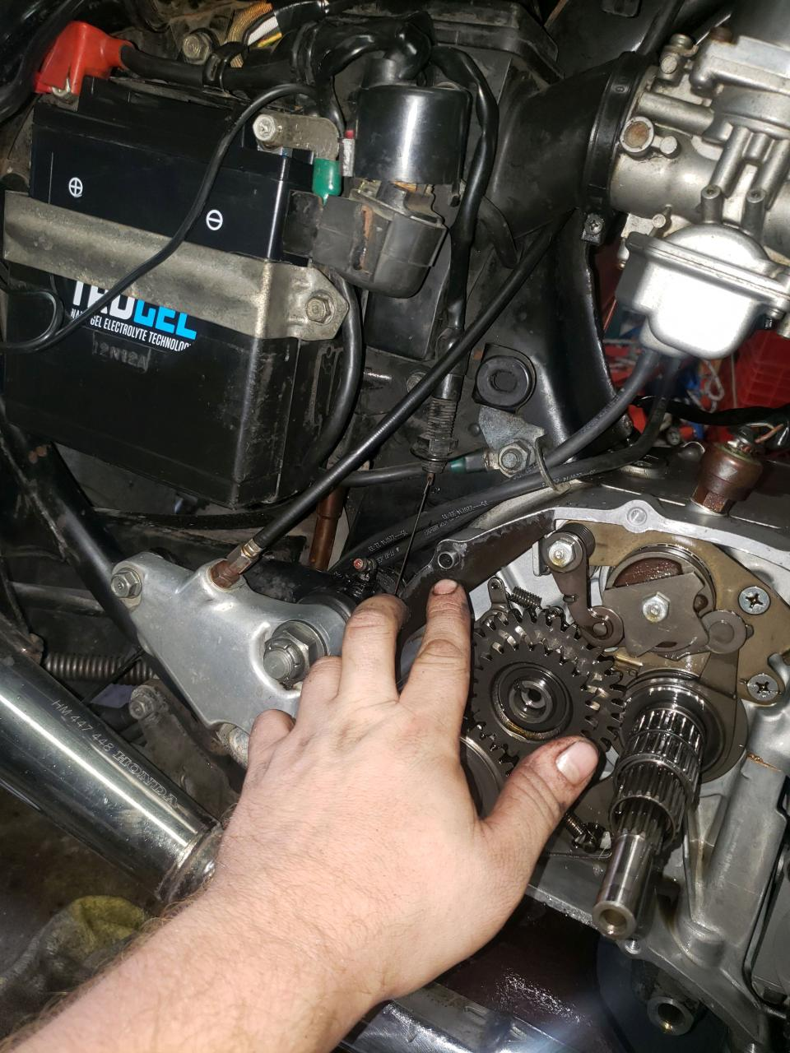

There is also one on the right. Same size as the left.
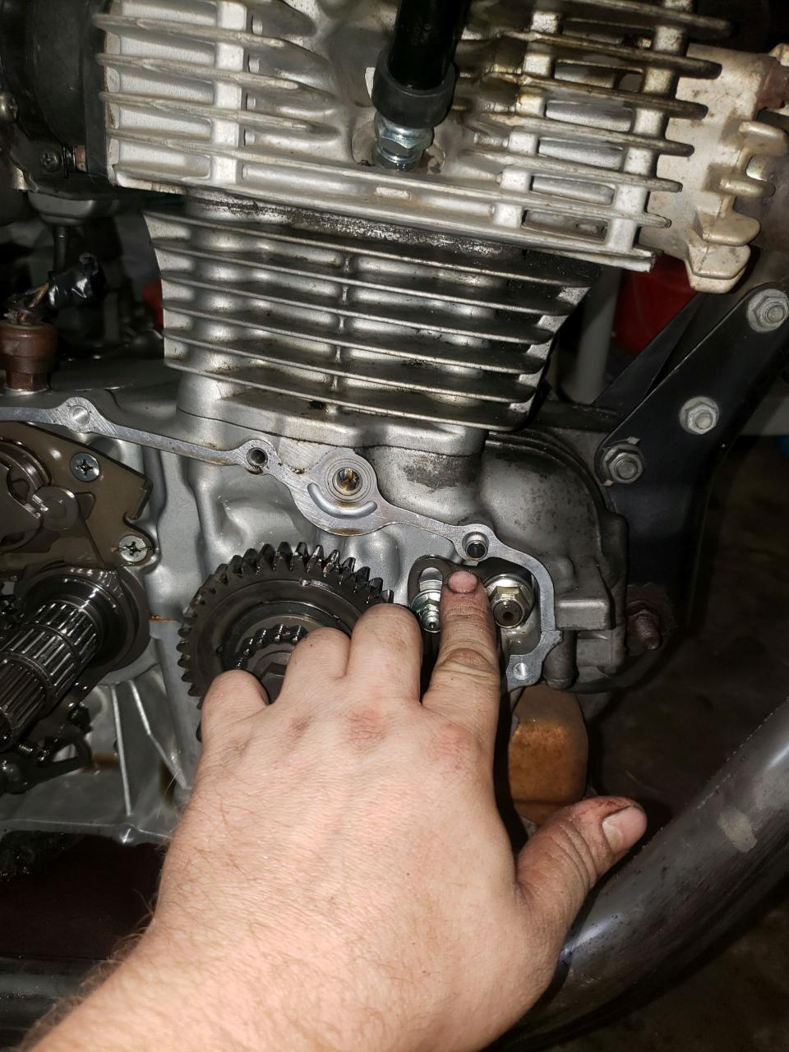

Now you adjust the tensioner the same as the 400T's. Loosen the 12mm and lightly loosen the 14mm. If it moves all the way down then you need to remove the 12mm nut entirely and move the spline to the next notch going counter clockwise. You can actually turn the shaft by hand lightly and watch through the cover to see the chain slack tighten. Get it where it needs to be and add the spline back on. If the punch mark on the shaft goes below the 9 o’clock/horizontal position after tightening the chain is completely worn and requires replacement.
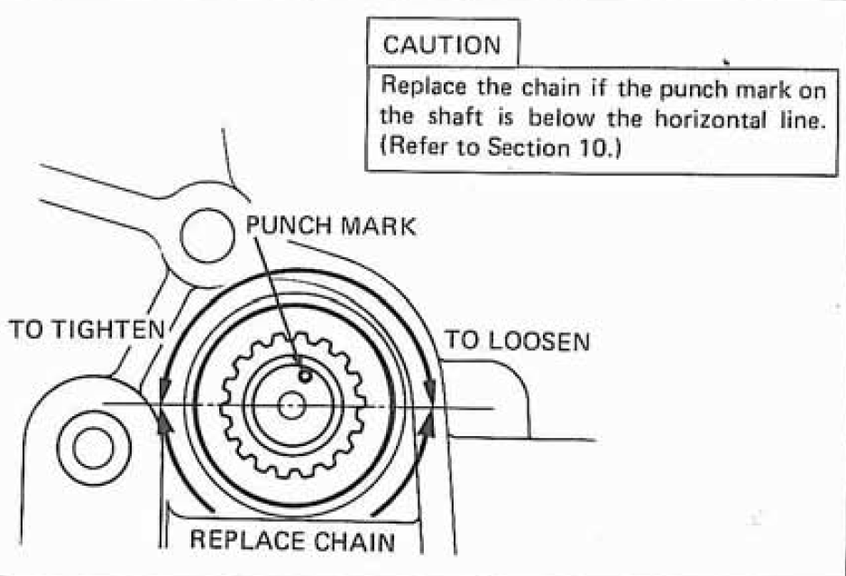
Before adjustment:
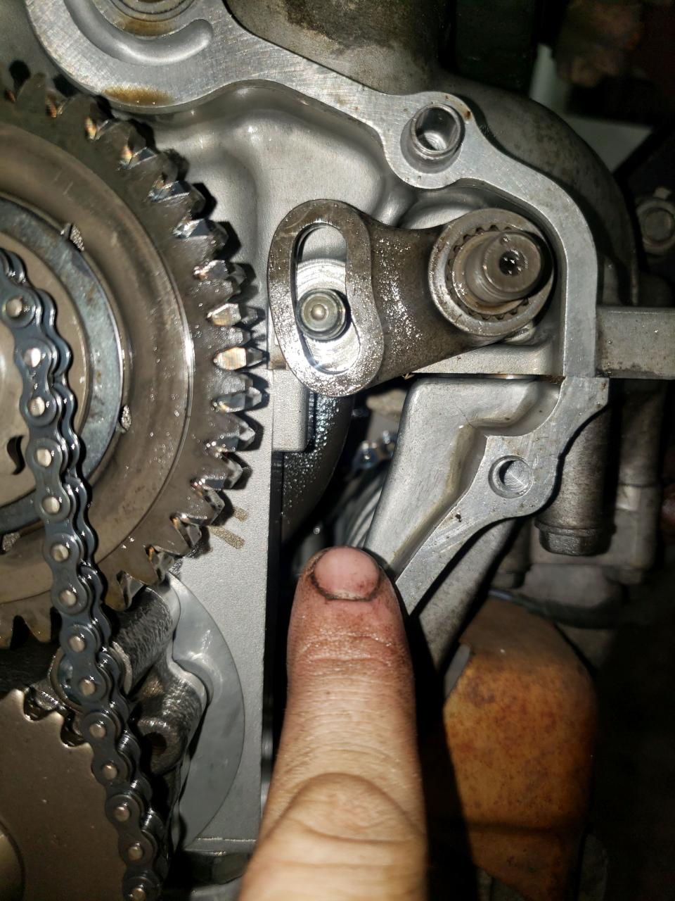
After adjustment:
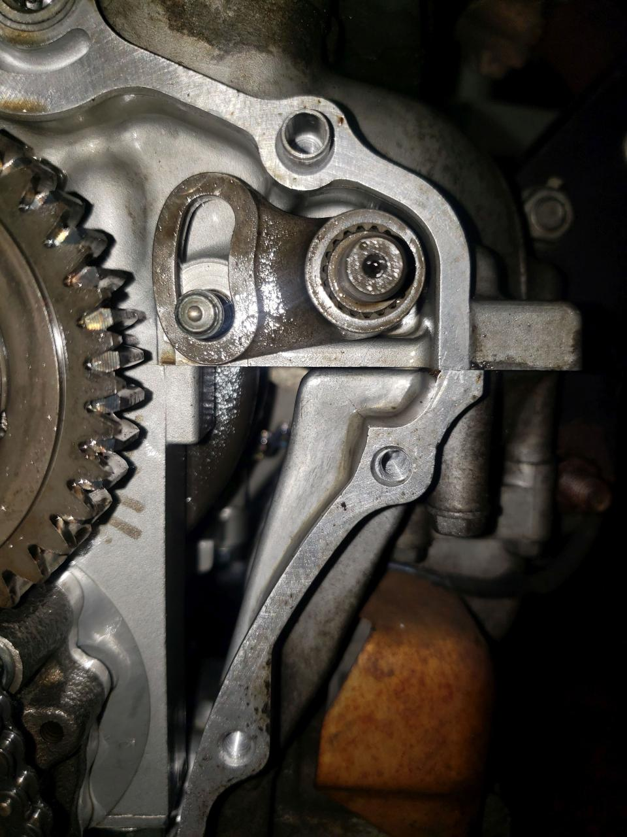
Put the 12mm and 14mm back on. Don't forget the washers.
Clean the gasket surfaces for the Inner and Outer Covers. On the Inner Cover there is an o-ring. You need to replace this. It's HPN: 91301-706-000, but it's NLA. It's simply a 17mm OD x 12mm ID x 2.5mm W o-ring. You can get a Viton replacement from MCM. Part number from MCM is 1185N96. Should be enough to last you 10 adjustments!
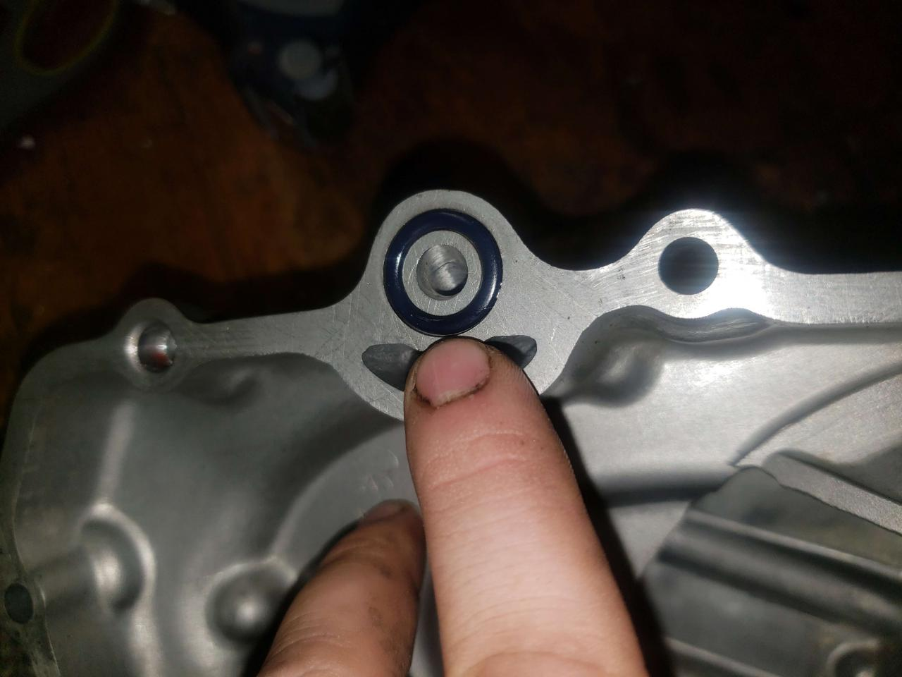

After you clean the gasket surfaces make sure there is no debris inside the covers. There are multiple passageways for the oil. Spray some break cleaner through those passages and make sure they're not clogged.
I have heard of people being tripped up on the installation of the torque converter. Once you know how to do it then it's not so bad.
When you start to put it on it will look like this:
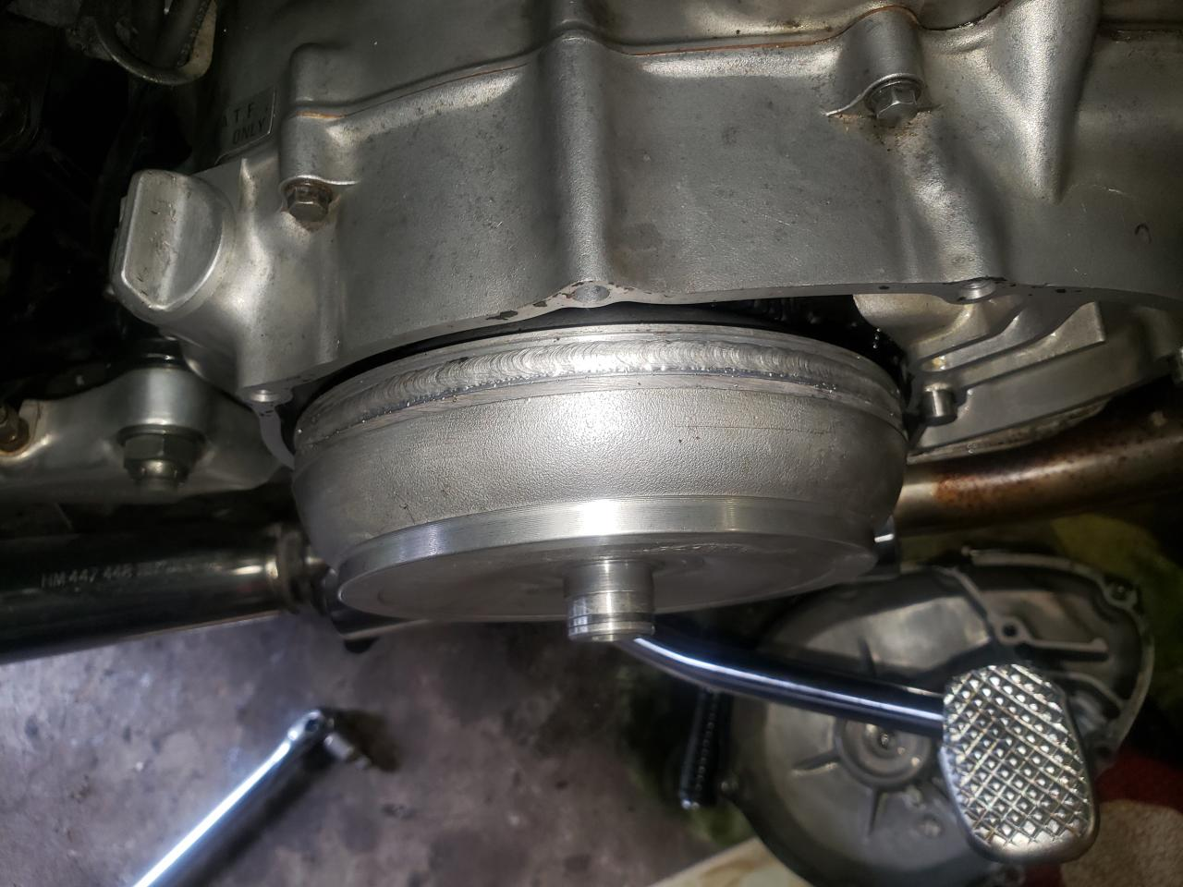
Move it around until the primary gear lines up. When this happens you'll be able to turn it slightly.
Now, put the bike in 1st gear. Don't do 2nd because it's a bit of pain to get it back into Neutral. If you make that mistake you'll have to get a helper and move the rear wheel back and forth while pushing down on the shifter.
Anyways, with the bike in gear slowly turn the rear wheel. You will see the shaft spinning. It will take a bit of play but it will eventually seat on the shaft. I have found you can spin the rear wheel backwards and forwards and usually when I go backwards a little bit it seats easily.

It should look like this when you reach this point. Notice the shaft is slightly exposed a few mm:
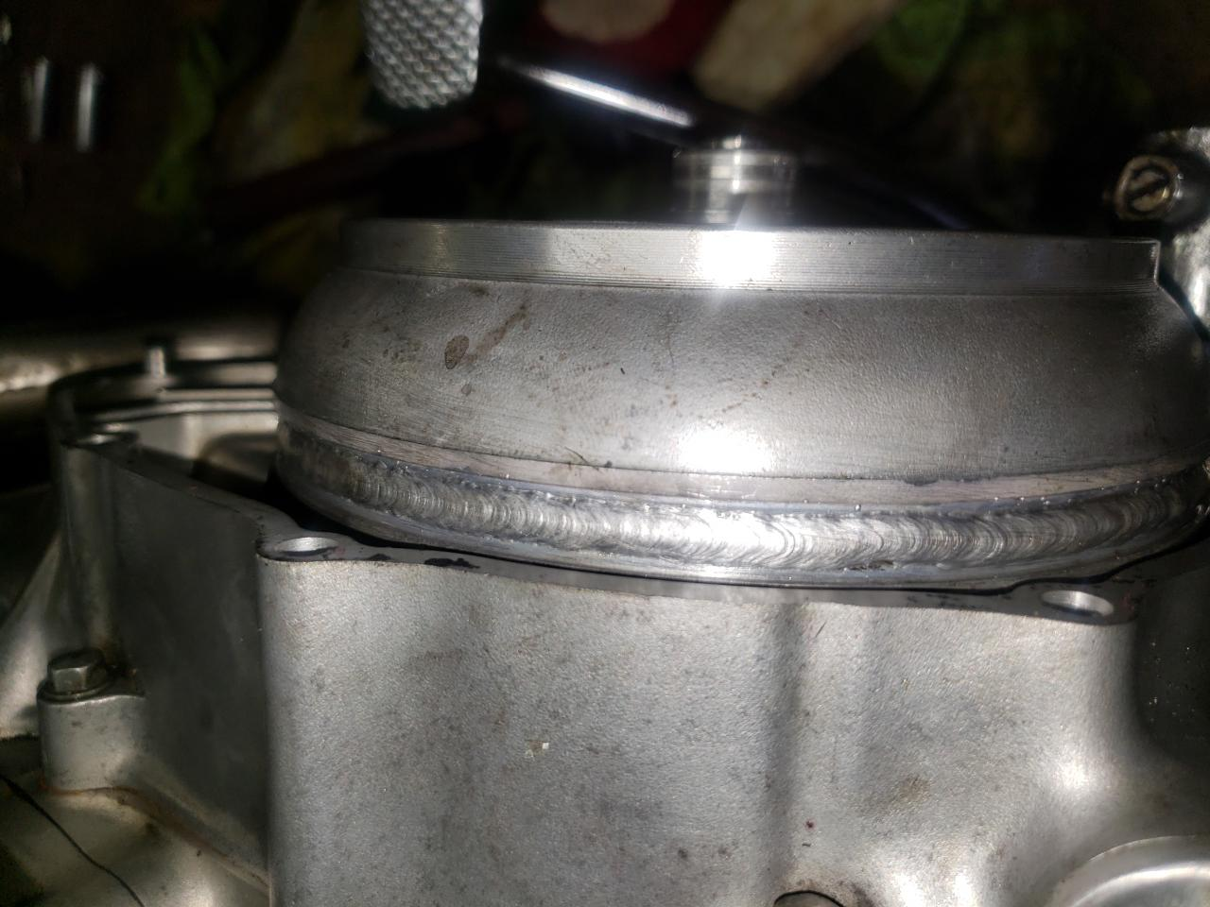
Now spin the torque converter with some light pressure applied and you'll find another notch and it will seat just a bit more like this:
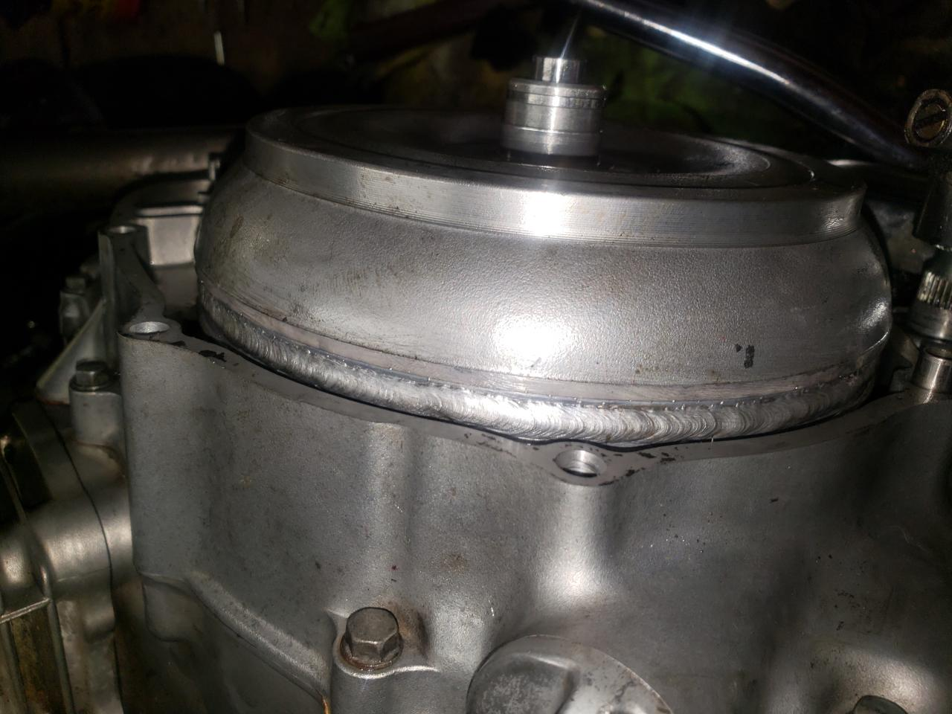
Attach the kickstarter lever and again spinning the torque converter with light pressure very lightly press down on the kickstarter with your hand. It should all line up and the torque converter should be fully flush. If the kickstarter does nothing that means you don't have the torque converter lined up with that smaller gear.
Once done it should all look like this:
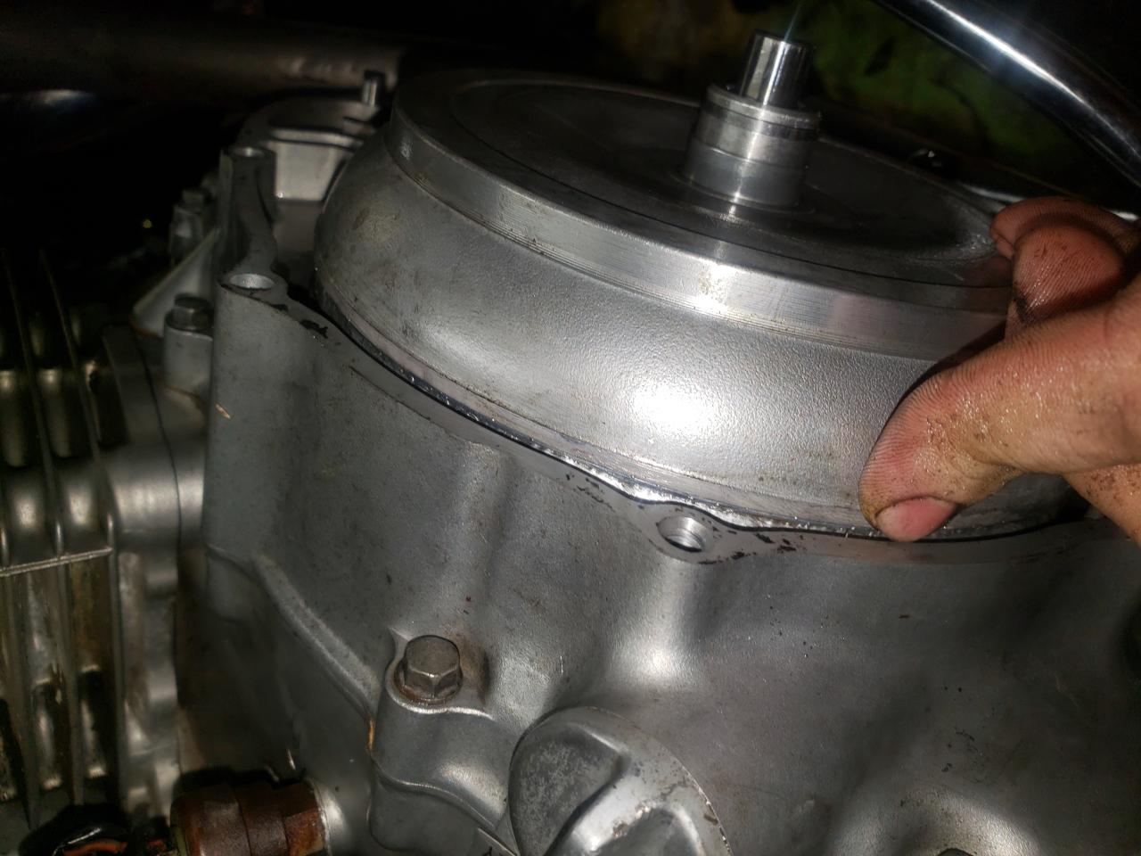
Put the cover back on, your foot peg and put oil back in the bike. Be sure to check the oil again after the initial start-up and top off as required.

Tool Recommendations
- T-Handle JIS Screwdriver: https://www.amazon.com/Handle-Screwdriver-Japanese-Standard-Screws/dp/B07V571J15
- Vessel JIS #2 Screwdriver: https://www.amazon.com/Vessel-Megadora-900-Screwdriver-Original/dp/B000TG8OTY
- Vessel JIS #3 Screwdriver: https://www.amazon.com/Vessel-P-3X150-STANDARD-MEGADORA-SCREWDRIVER/dp/B004VDBQ6O
- Motion Pro Valve Tappet Adjuster: https://www.motionpro.com/product/08-0735
- Motion Pro Feeler Gauge .002-.003: https://www.motionpro.com/product/08-0392
- Motion Pro Feeler Gauge .004-.005: https://www.motionpro.com/product/08-0393
- Motion Pro Feeler Gauge .006-.008: https://www.motionpro.com/product/08-0394
- Lang Tools 14 Blade Valve Lash Gauge Set: https://www.ebay.com/itm/233538544957
- Motion Pro Chain Alignment Tool: https://www.motionpro.com/product/08-0048
- Motion Pro Flywheel Puller: https://www.motionpro.com/product/08-0086
- Neiko 3/8” Drive Allen Set: https://www.amazon.com/Neiko-01130B-8-Inch-Metric-Driver/dp/B000JOR0J6
- Neiko 3/8” Drive T-Handle: https://www.amazon.com/Neiko-01135A-Chromium-Vanadium-Adaptors/dp/B000VUUFIQ
- Thexton THE115 Battery Hydrometer: https://www.amazon.com/dp/B000P6WS22
- Foval Automatic Trickle Charger 1A: https://www.amazon.com/dp/B074Z2NFWW
- Generic 9pc Punch Set: https://www.amazon.com/dp/B07JNS1ZF7
- Generic Motorcycle Chain Brush: https://www.amazon.com/gp/product/B0719CFFPP
- Lisle Spark Plug Gapper: https://www.amazon.com/gp/product/B0009OR90Q
- OTC 5605 Compression Tester Kit: https://www.amazon.com/OTC-5605-Deluxe-Compression-Tester/dp/B004K2FSXI
- AC Delco 1/2" Torque Adapter: https://www.amazon.com/ACDelco-Digital-Adapter-Audible-ARM602-4A/dp/B07DV33XJ5
- Innova 3551 Inductive Timing Light: https://www.amazon.com/INNOVA-3551-Inductive-Timing-Light/dp/B000EVYH72
- Generic Flywheel/Clutch Holder Tool: https://www.amazon.com/gp/product/B0963XXXRF
- ESI 640 Peak Voltage Adapter: https://www.amazon.com/dp/B0093U3TFG
- Bravex Heavy Duty Pistol Grip Grease Gun: https://www.amazon.com/dp/B07BK2ZD4N
- Wera 05110006001 Slotted Screwdriver 4mm: https://www.amazon.com/dp/B00365EXX6
- Anex Ultra-low Profile Offset Ratcheting Screwdriver: https://www.amazon.com/dp/B0028DDD2Y
- Mityvac MV8500 Silverline Elite: https://www.amazon.com/dp/B0002SQYUA
- Motion Pro Pilot Screw Adjustment Tool: https://www.amazon.com/dp/B000UKD6YC

Oil, Lube, Misc. Fluids Recommendations:
- Honda GN4 10W40 Conventional: https://prohondaoils.com/product/gn4-premium-conventional/
- Shell Rotella T4 15W40: https://www.amazon.com/dp/B01LH7L0XA
- Honda SS-8 10W Fork Oil: https://prohondaoils.com/product/ss-8-suspension-fluid/
- PJ1 Control Cable Lube: https://pj1.com/product/cable-lube/
- Maxima Chain Wax Aerosol: https://maximausa.com/series-279-chain-wax.html
- Sta-bil 360 Marine Fuel Stabilizer: https://www.amazon.com/STA-BIL-22241-Marine-Vapor-Technology/dp/B002G11GOA
- 3-in-1 Blue Oil/SAE 20: https://www.amazon.com/3-IN-ONE-Motor-Oil-3-OZ/dp/B00065VGUC
- Lucas Red “N” Tacky Grease: https://www.amazon.com/Lucas-Oil-Red-Tacky-Grease/dp/B0068C5WD4
- CRC QD Electronic Contact Cleaner: https://www.amazon.com/CRC-05103-Electronic-Cleaner-11
- Permatex Dielectric Tune-Up Grease: https://www.amazon.com/Permatex-22058-Dielectric-Tune-Up-Grease/dp/B000AL8VD2
- Permatex Anti-Seize Lubricant: https://www.amazon.com/Permatex-80078-Anti-Seize-Lubricant-Bottle/dp/B01LRH8R54
- CRC Brakleen: https://www.amazon.com/CRC-05089-BRAKLEEN-Brake-Cleaner/dp/B000LDR9HI
- Red Rubber Grease: https://www.amazon.com/GENUINE-Corrosion-Oxidation-Resistant-TS-2-34-04/dp/B01L63YQ4U
- AGS Sil-Glyde: https://www.amazon.com/AGS-SIL-Glyde-Multi-Purpose-All-Weather-Lubricating/dp/B000KXLR5E
- Berryman Professional Carb Cleaner: https://www.amazon.com/Berryman-Chemtool-Carburetor-Throttle-compliant/dp/B0002KKIDW
- Bike Master TruGel Battery M12A-4A1: https://www.amazon.com/dp/B00GO4JBOM/
- Maxima DOT5 Silicone Brake Fluid: https://www.amazon.com/dp/B07MQX68GM
- CEC Industries EF32 Heavy Duty 12V Flasher: https://www.amazon.com/gp/product/B0031GYS6W

