**NOTICE**

The 6-pin canon plug for the Stator is different from the original. Unfortunately, I have been unable to source the correct orientation from suppliers as of October, 2023. However, this is not fatal and will not affect operation in any way. Included is a new male connector which does latch. You can extract the old terminals with a pick tool or tiny flathead on the male connector from the stator and use the new connector.

Alternatively, you can leave it plugged in and it will work fine. If you are concerned about it coming loose (it shouldn’t) then simply use a zip tie in the center or put a dab of RTV on the outside of the connector housing to hold it in place. If you decide to go this route I have attached pictures of the keying as it is different. Double check wire colours from each end to be sure they are aligned properly.

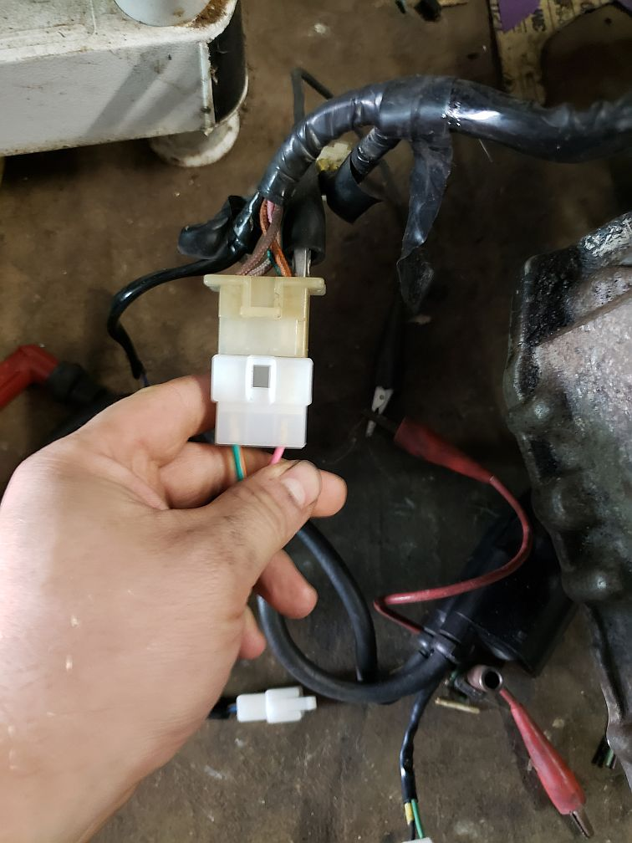 **- Wrong alignment.**

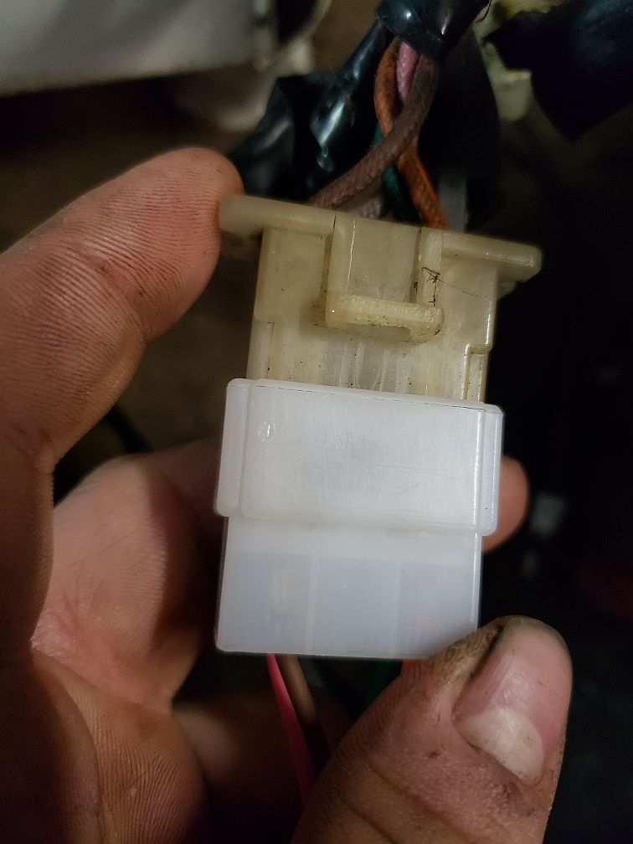 **- Correct alignment, notice the keying on the sides.**

Support, questions, comments? Visit us at <https://www.hondamaticparts.com>.