**Dyna DC11-2 Ignition Coil Kit Instructions**

The Dyna coil kit will give you better spark under load as well as a smoother idle. You can even go a step further and set the spark gap at 0.035” up to 0.040” for better idling, improved throttle response, and in some cases may improve fuel economy a little bit.

The only real thing you need to know when installing is the coil is installed upside down and the side with no logo is facing out. Do not install it with the logo facing out as the tower and boots will rub against the frame and could cause it to crack.

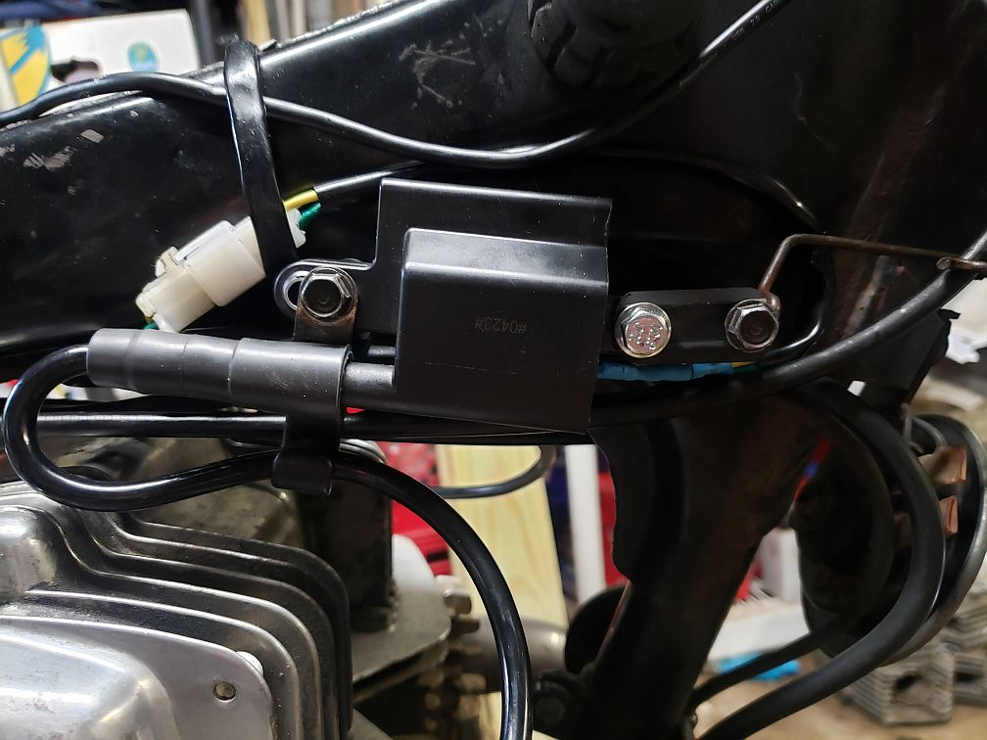

This is the correct mounting. The smaller spacer goes on the left side and the larger one goes on the right. Make sure the boots are seated firmly on the towers. If unsure you can probe the inside of each cap with an ohm meter from both ends. If you’re getting continuity (~16-26Kohm) then you are good to go.

Support, questions, comments? Visit us at <https://www.hondamaticparts.com>.